# **Name: Abdurrahman Qureshi**

# **Roll No: 210451**

Practical No: 13

**1)Perform automation testing on notepad via Auto-IT**

1. **Display text on notepad**

**CODE:**

run("notepad.exe")

WinWaitActive("EXP17Victim.txt ‎- Notepads")

Send("qarq90 is testing on this text document")

**OUTPUT:**

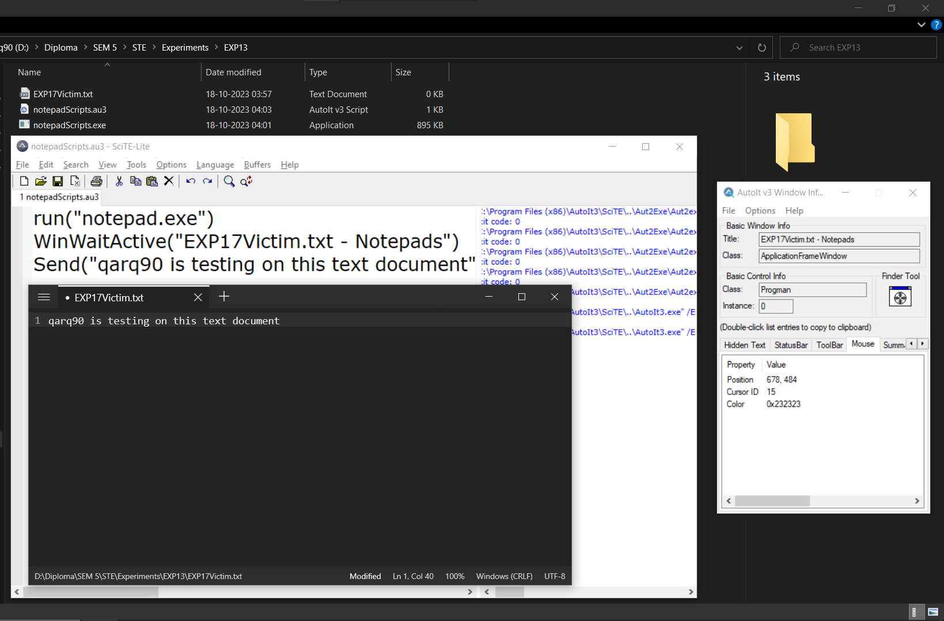

1. **Do Cut, Copy and Paste.**

**CODE:**

Run("notepad.exe")

WinWaitActive("Untitled - Notepad")

Send("First we copy then we paste next we cut and put it back")

Send("+{HOME}")

Send("^c")

Send("{RIGHT}")

Send("{ENTER}")

Send("^v")

Send("{ENTER}")

send("{UP}{UP}")

Send("{HOME}")

Send("+{END}")

Send("^x")

Send("^{END}")

Send("^v")

**OUTPUT:**

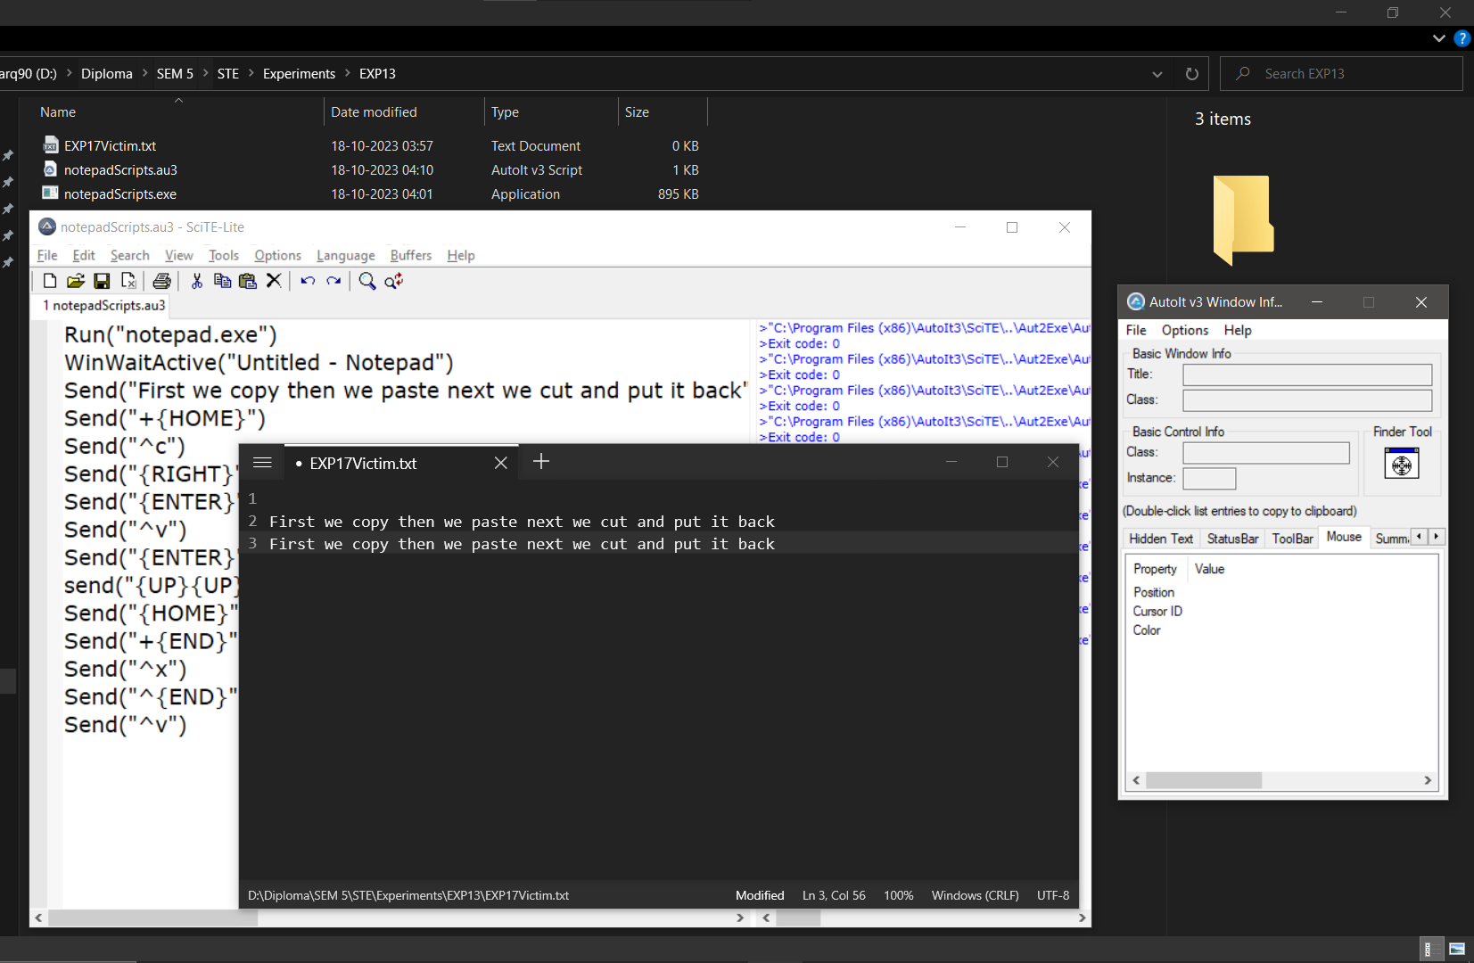

1. **Display Text in Alternate Line.**

**CODE:**

Run("notepad.exe")

WinWaitActive("EXP17Victim.txt ‎- Notepads")

Send("time to go to an ulturnate line")

Send("{ENTER}{ENTER}")

Send("time to ulturnate --- question no.3 - 2023")

**OUTPUT:**

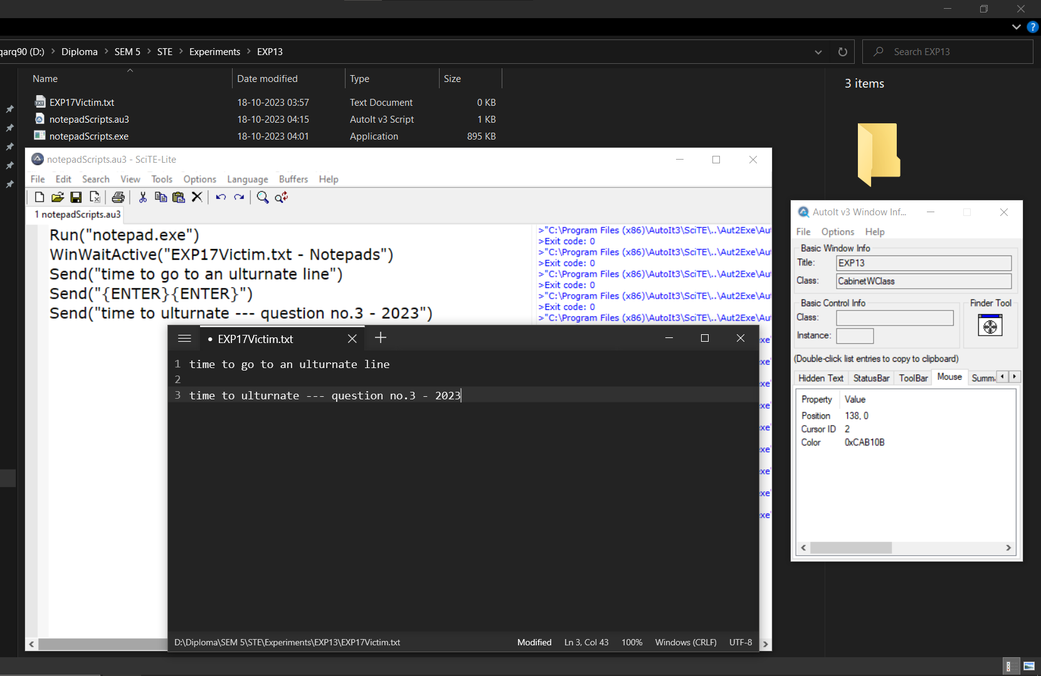

1. **Save File.**

**CODE:**

Run("notepad.exe")

WinWaitActive("Untitled - Notepad")

Send("lets save this file")

Send("^s")

WinWaitActive("Save as")

Send("Saving")

Sleep(2000)

Send("{ENTER}")

**OUTPUT:**

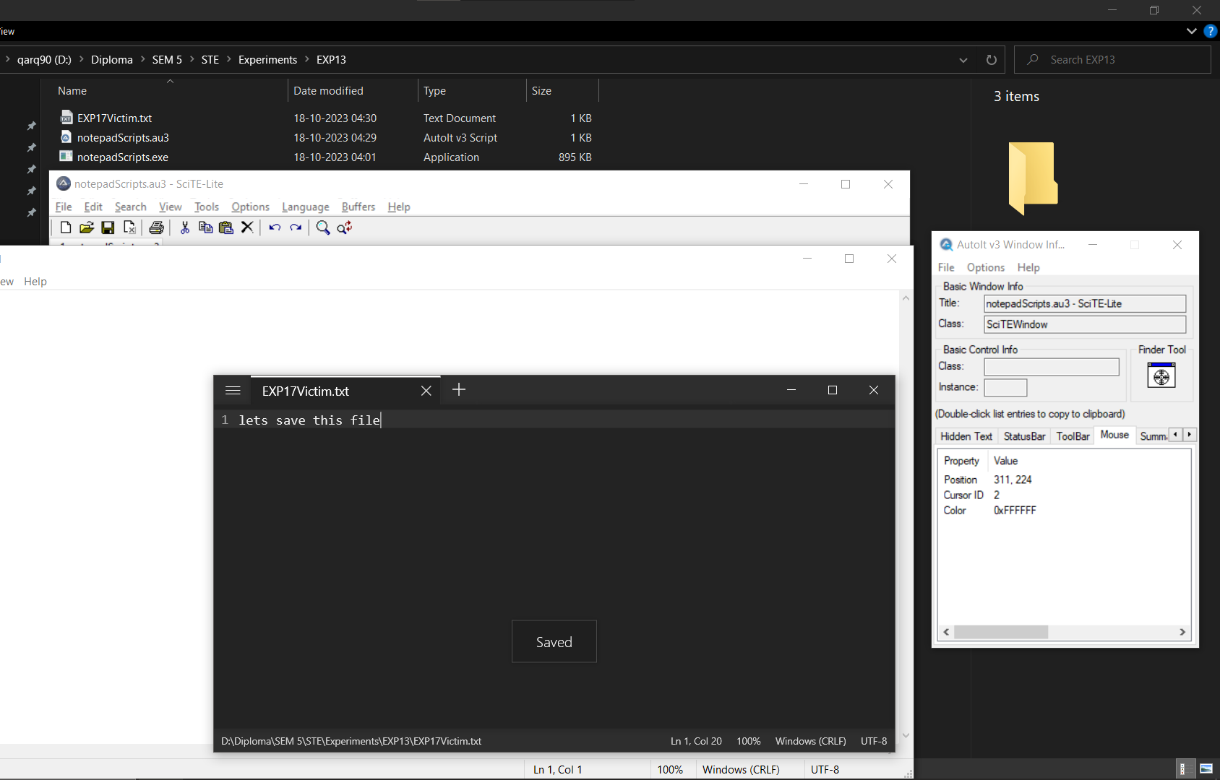

1. **Exit without closing**

**CODE:**

run("notepad.exe")

WinWaitActive("EXP17Victim.txt ‎- Notepads")

Send("i m not in mood to save this txt file")

Send("^w")

SEnd("{RIGHT}")

Send("{ENTER}")

**OUTPUT:**

